Figure 1: Spring Boot project structure implementing layered architecture.
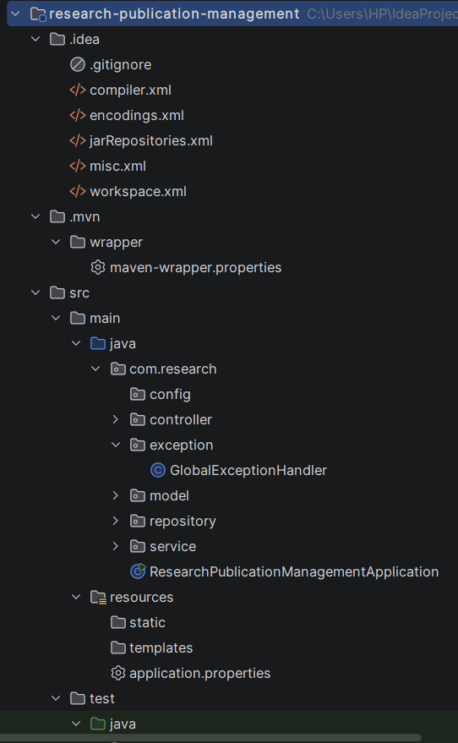

Figure 2: MongoDB database configuration.
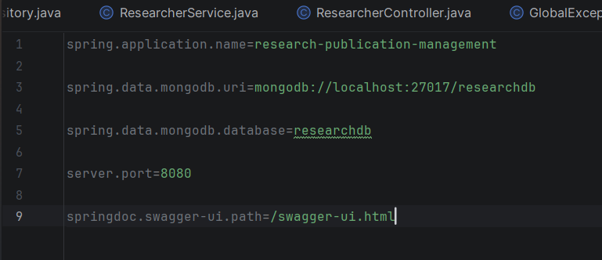

Figure 3: REST APIs exposed through Swagger UI.
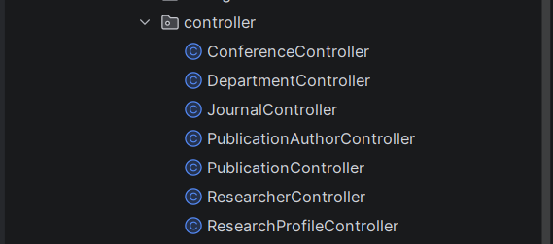

Figure 4: Department creation using REST API.
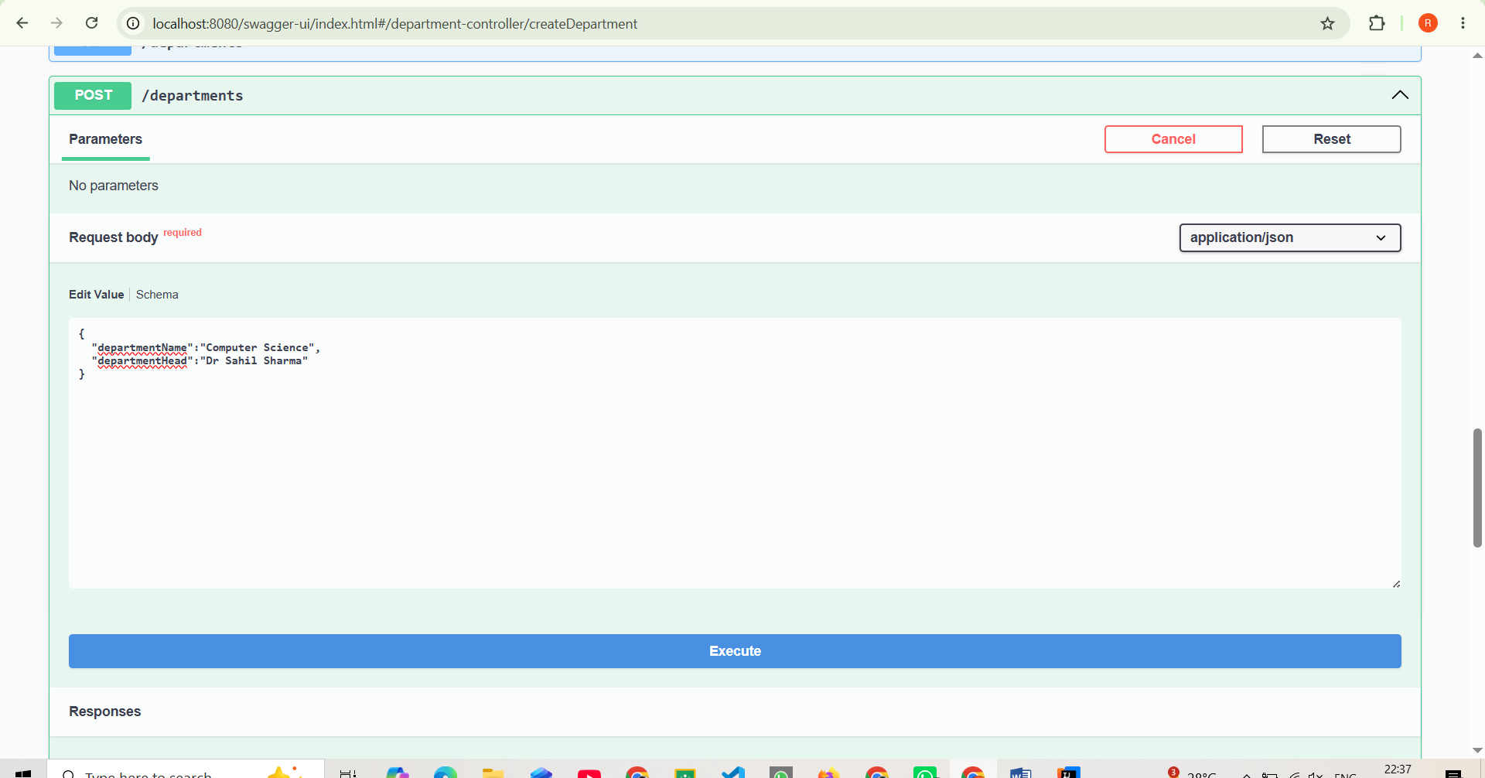

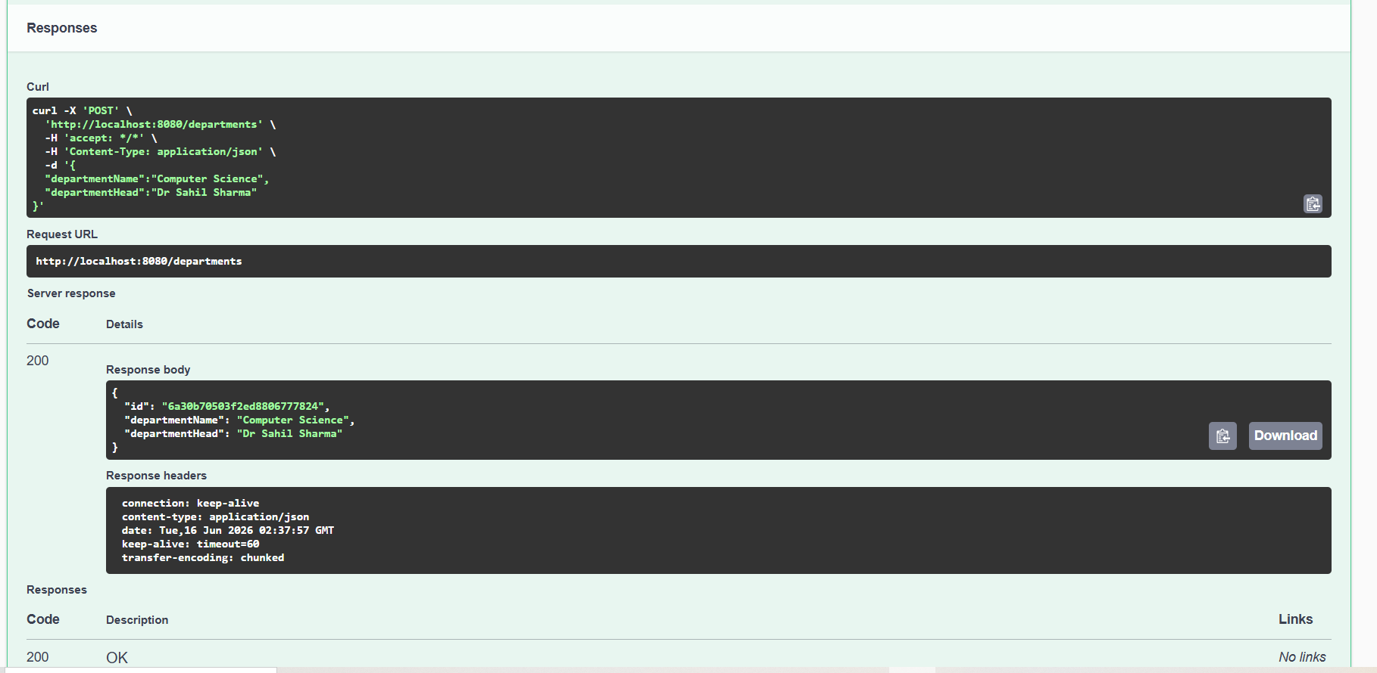

Figure 5: Input validation using Spring Validation.
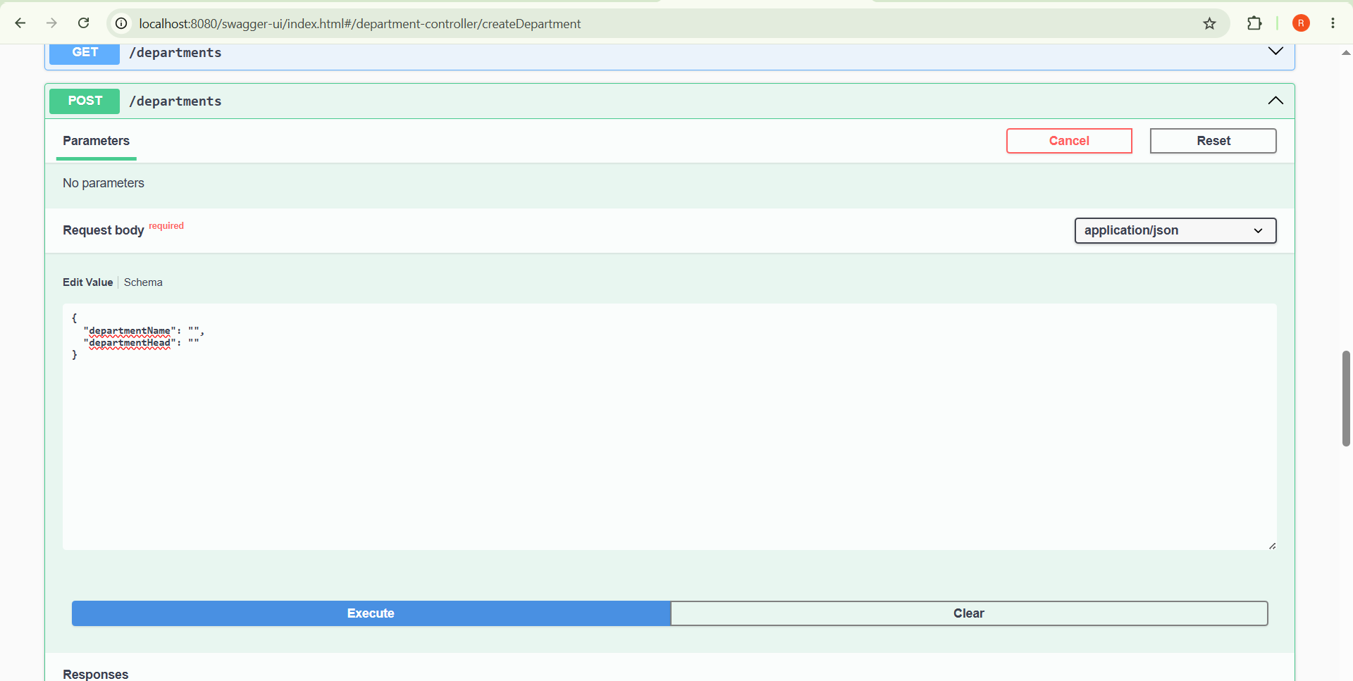
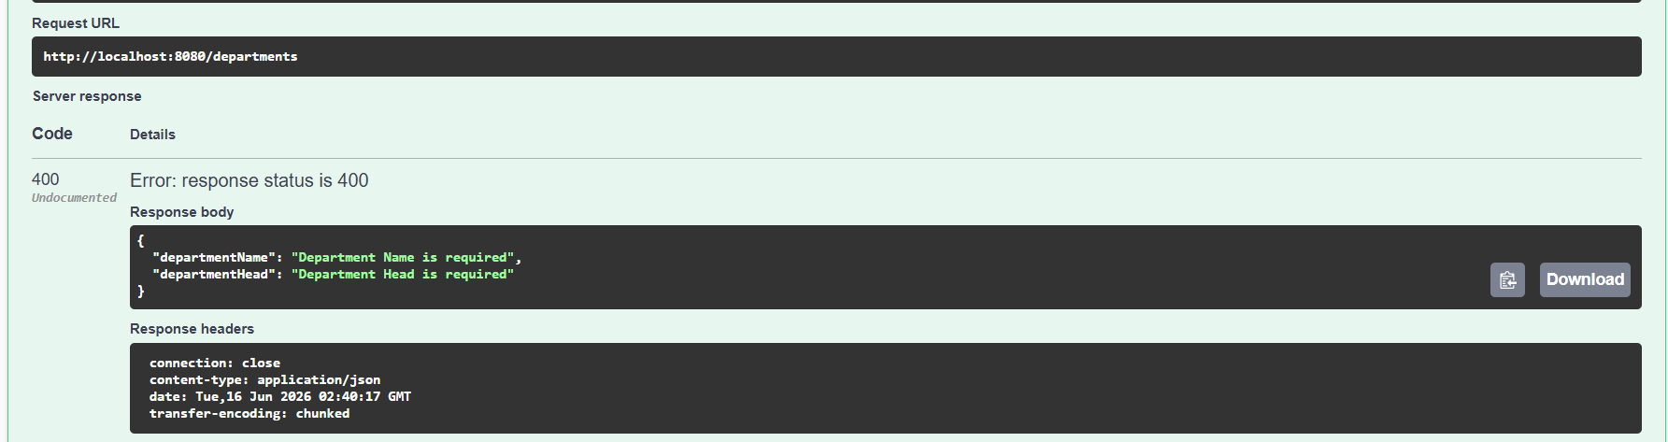

Figure 6: MongoDB collections created by the application.
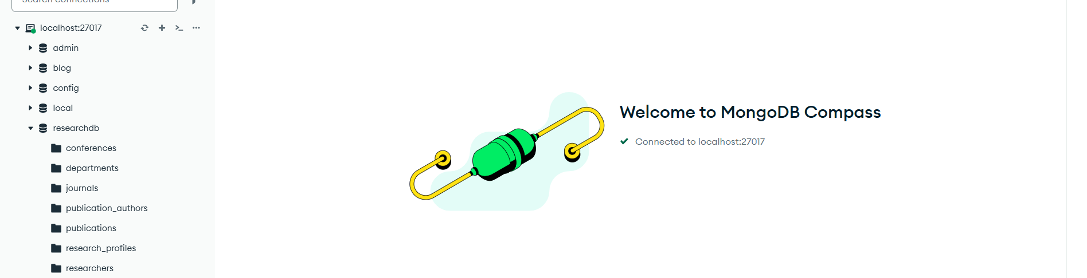

Figure 7: Department records stored in MongoDB.

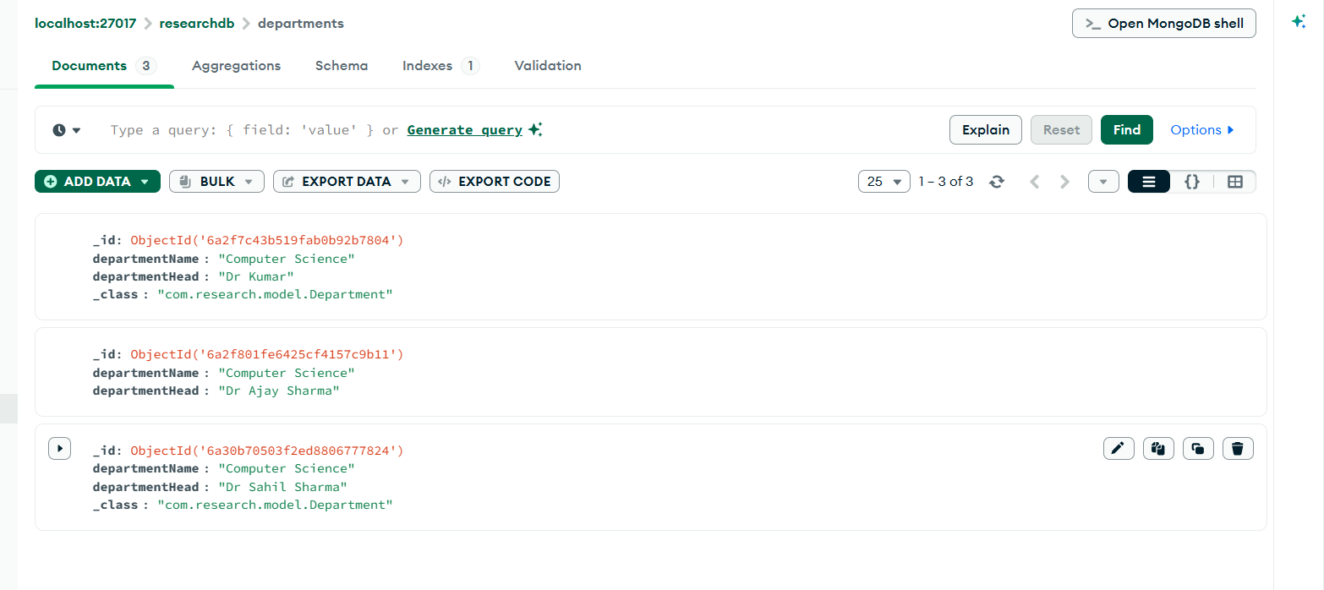

CRUD OPERATION:
CREATE:

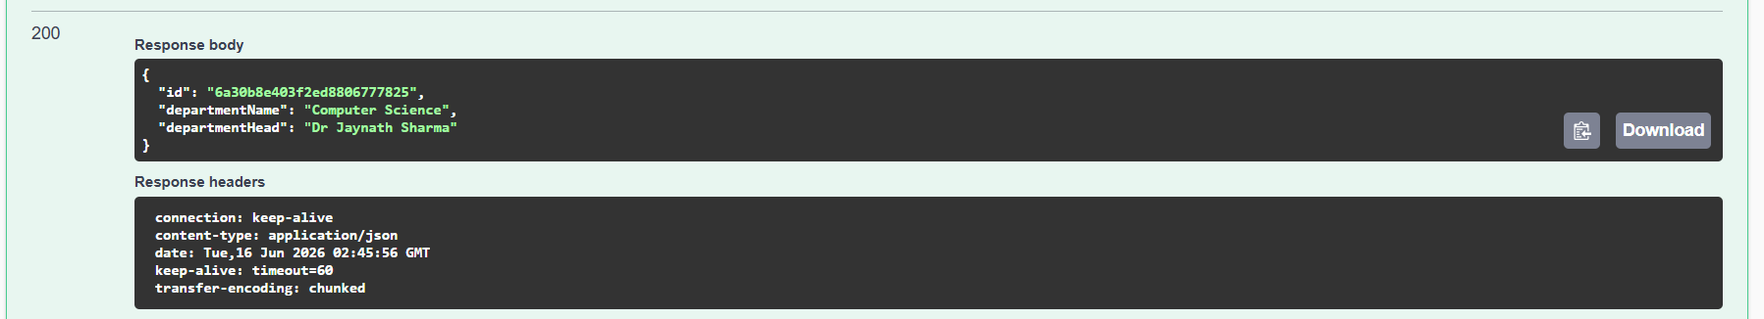
READ:
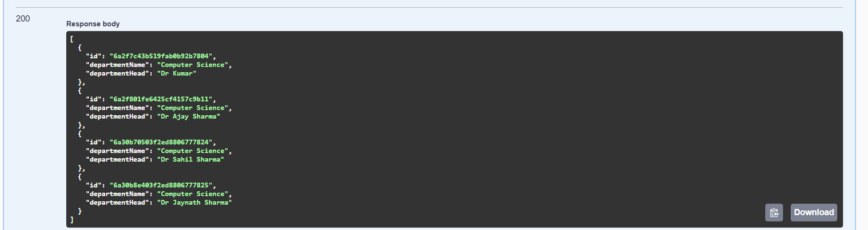

UPDATE:
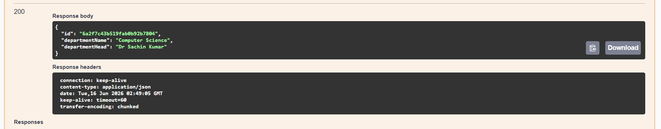
DELETE:
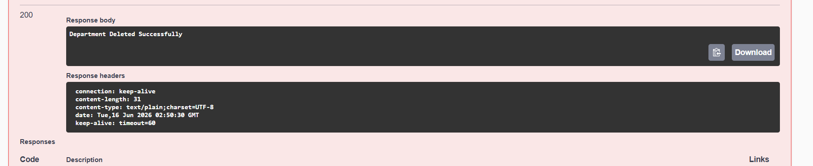

MONGODB DEPARTMENT

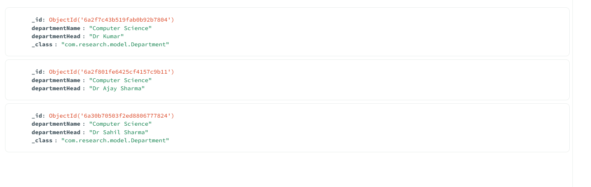

SCHEMA :
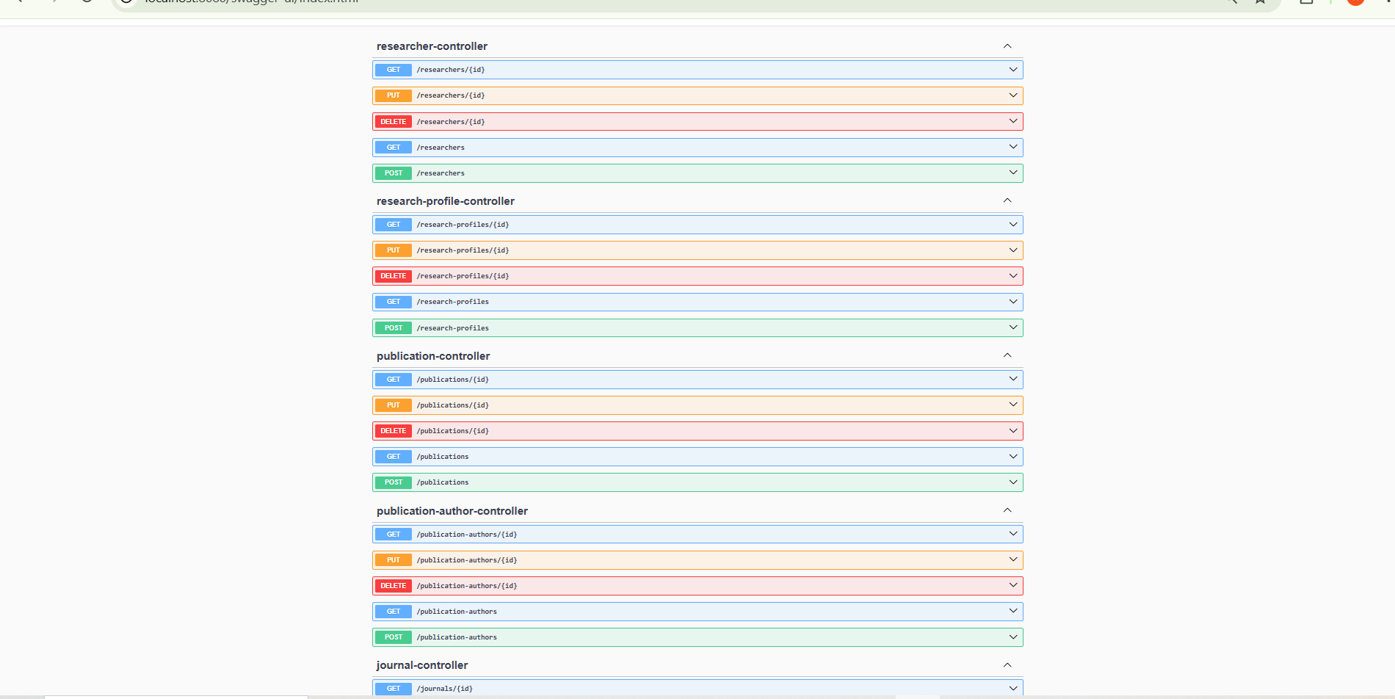

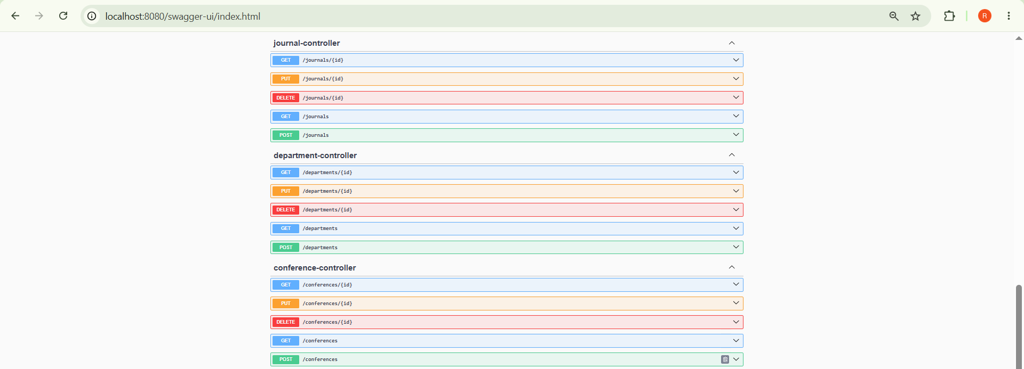

FINAL SCHEMA:
